

**Starting a business?**

**Talk to Anita Fettig of Nita's Attic about small business ownership!**

**Monday, January 29, 2018**

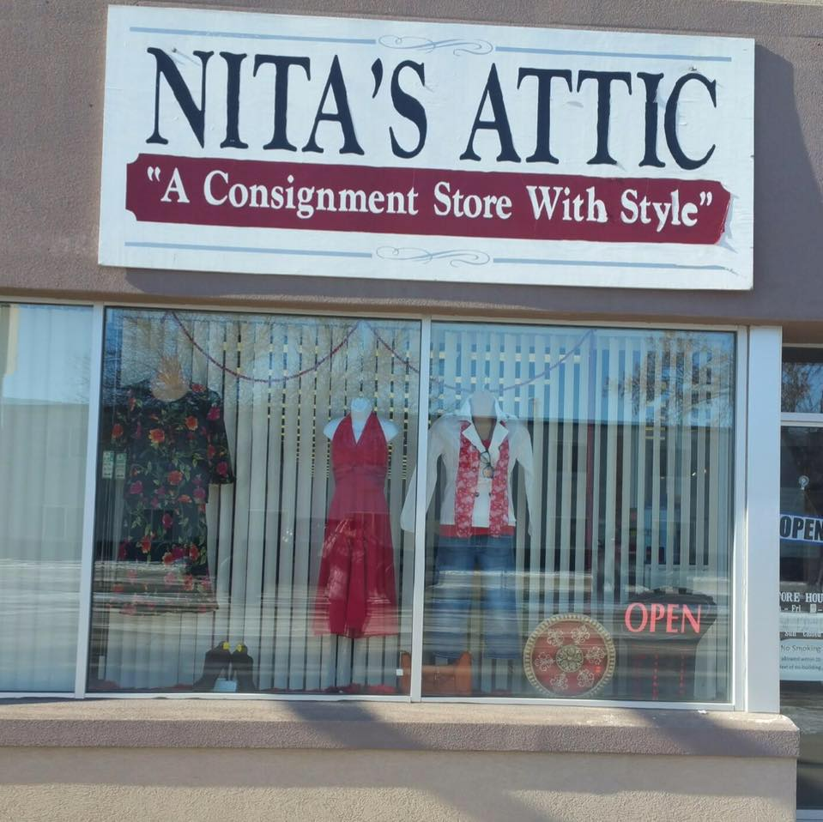**4:30 p.m. – 5:30 p.m.**

Join us for a discussion with Anita Fettig, owner of Nita’s Attic in Napoleon and Jamestown, as we learn more about her journey into starting several small businesses. This is a free event. Light refreshments will be provided. No registration is required.

**Event location:**

White Maid Diner 301 Main Avenue, Napoleon, ND 58561

For more information, contact the Jamestown Regional Entrepreneur Center at Katherine.Roth@uj.edu or 701-253-4112.

**Event is hosted by the Jamestown Regional Entrepreneur Center | JREcenter.com**